**Hashicorp Configuration Language (HCL) for Terraform**

* For Specification <https://github.com/hashicorp/hcl/blob/main/hclsyntax/spec.md>
* Terraform release <https://releases.hashicorp.com/terraform/>
* Provider <https://developer.hashicorp.com/terraform/language/providers>

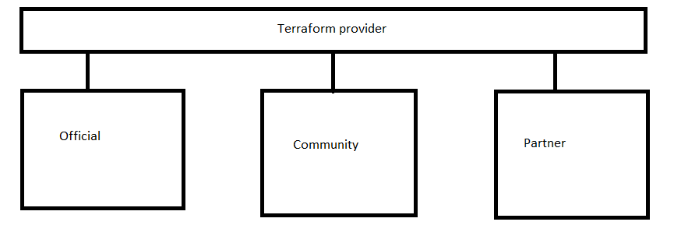**The terraform block helps in configuring the provider with version of the provider from registry** <https://developer.hashicorp.com/terraform/language/settings>

* Specify which version of terraform you should be using use required version. To specify constraints <https://developer.hashicorp.com/terraform/language/expressions/version-constraints>
* main.tf file <https://github.com/asquarezone/TerraformZone/commit/ccf6a7c9dd7c97a607d920323e16bc5b3a8339d3>

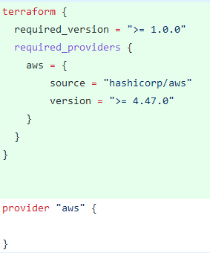

Note: By default, terraform pick latest configuration.

How to read version in terraform 1.4.5[<majorVersion><minorVersion><patchSet>]

**Parametrizing Terraform**

**Input Variables**

* <https://developer.hashicorp.com/terraform/language/values/variables> for input variables official docs
* For inputs terraform supports the following types
  + number
  + string
  + boolean
  + list()
  + set()
  + map()
  + object({ = , … })
  + tuple([, …])
* To pass variables while executing commands we have two options
  + -var
  + -var-file
* using -var <https://developer.hashicorp.com/terraform/language/values/variables#variables-on-the-command-line>

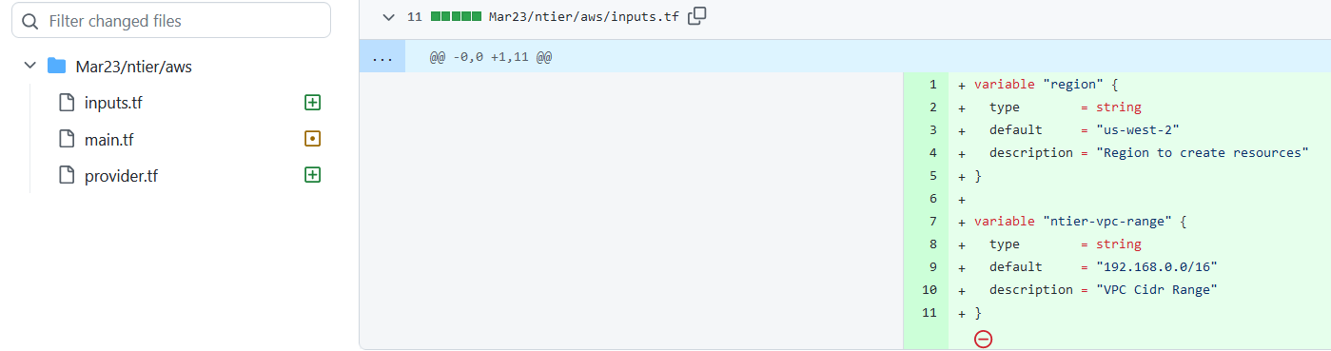

Command: terraform apply -var "region=ap-south-2" -var "ntier-vpc-range=10.10.0.0/16"

* using variable definitions <https://developer.hashicorp.com/terraform/language/values/variables#variable-definitions-tfvars-files> , example terraform apply -var-file values.tfvars 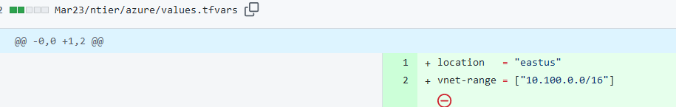
* Instead of creating multiple var file we can create 1 values.tfvars where we can define all the variable in once like above.